Given a *m* x *n* grid. Each cell of the grid represents a street. The street of grid[i][j] can be:

* **1** which means a street connecting the left cell and the right cell.
* **2** which means a street connecting the upper cell and the lower cell.
* **3** which means a street connecting the left cell and the lower cell.
* **4** which means a street connecting the right cell and the lower cell.
* **5** which means a street connecting the left cell and the upper cell.
* **6** which means a street connecting the right cell and the upper cell.

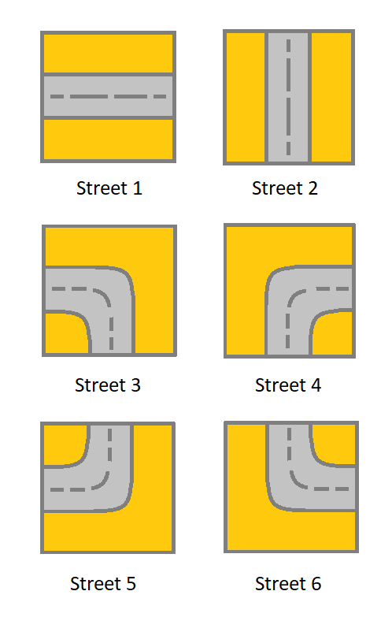

You will initially start at the street of the upper-left cell (0,0). A valid path in the grid is a path which starts from the upper left cell (0,0) and ends at the bottom-right cell (m - 1, n - 1). **The path should only follow the streets**.

**Notice** that you are **not allowed** to change any street.

Return *true* if there is a valid path in the grid or *false* otherwise.

**Example 1:**

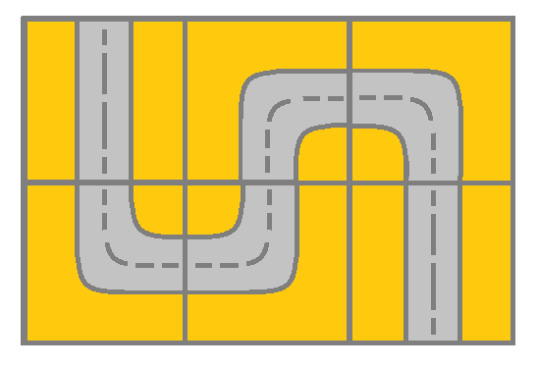

**Input:** grid = [[2,4,3],[6,5,2]]

**Output:** true

**Explanation:** As shown you can start at cell (0, 0) and visit all the cells of the grid to reach (m - 1, n - 1).

**Example 2:**

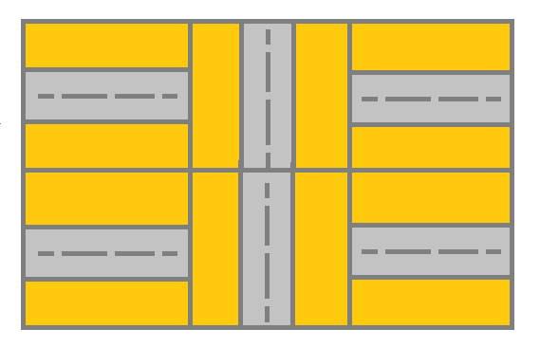

**Input:** grid = [[1,2,1],[1,2,1]]

**Output:** false

**Explanation:** As shown you the street at cell (0, 0) is not connected with any street of any other cell and you will get stuck at cell (0, 0)

**Example 3:**

**Input:** grid = [[1,1,2]]

**Output:** false

**Explanation:** You will get stuck at cell (0, 1) and you cannot reach cell (0, 2).

**Example 4:**

**Input:** grid = [[1,1,1,1,1,1,3]]

**Output:** true

**Example 5:**

**Input:** grid = [[2],[2],[2],[2],[2],[2],[6]]

**Output:** true

**Constraints:**

* m == grid.length
* n == grid[i].length
* 1 <= m, n <= 300
* 1 <= grid[i][j] <= 6